Government of India
Ministry of Youth Affairs & Sports
Department of Sports
Mission Directorate

Annexure – I

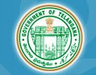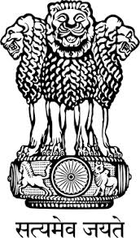

No...................

MANDAL LEVEL RURAL COMPETITIONS UNDER RAJIV GANDHI KHEL ABHIYAN (RGKA) FOR THE YEAR 2014-15

.................................Mandal TELANGANA STATE

CERTIFICATE OF MERIT

It is certified the Mr/Miss......................................................... Son/Daughter of Sri............................................, whose Date of Birth is .....................representing .................................. village Panchayat has participated in the Discipline of .............. ................................... in ................................event with ................................... Timing/Distance/Height/Points and secured ....................Position in the Mandal Rural Competitions held at ........................... from ................... to .................. organized by State Sports Department/State Sports Council/State Sports Authority.

Mandal Development Officer

.......................................

